Maria Nino

Rockbuster Stealth

Data Dictionary

Table of Contents

1. Rockbuster Data Set 2

2. Entity Relationship Diagram 3

3. Tables 4

3.1 Payment table: 4

3.2 Rental table: 4

3.3 Film_actor table: 5

3.4 Inventory table: 5

3.5 Film_category table: 5

3.6 Customer table: 6

3.7 Staff table: 6

3.8 Store table: 7

3.9 Actor table: 7

3.10 Film Table: 8

3.11 Category table: 8

3.12 Address table: 9

3.13 Language table: 9

3.14 City table: 9

3.15 Country table: 10

# 1. Rockbuster Data Set

The data set contains information about Rockbuster’s customers, staff members, film inventory, sales data, and locations of people and stores.

# 2. Entity Relationship Diagram

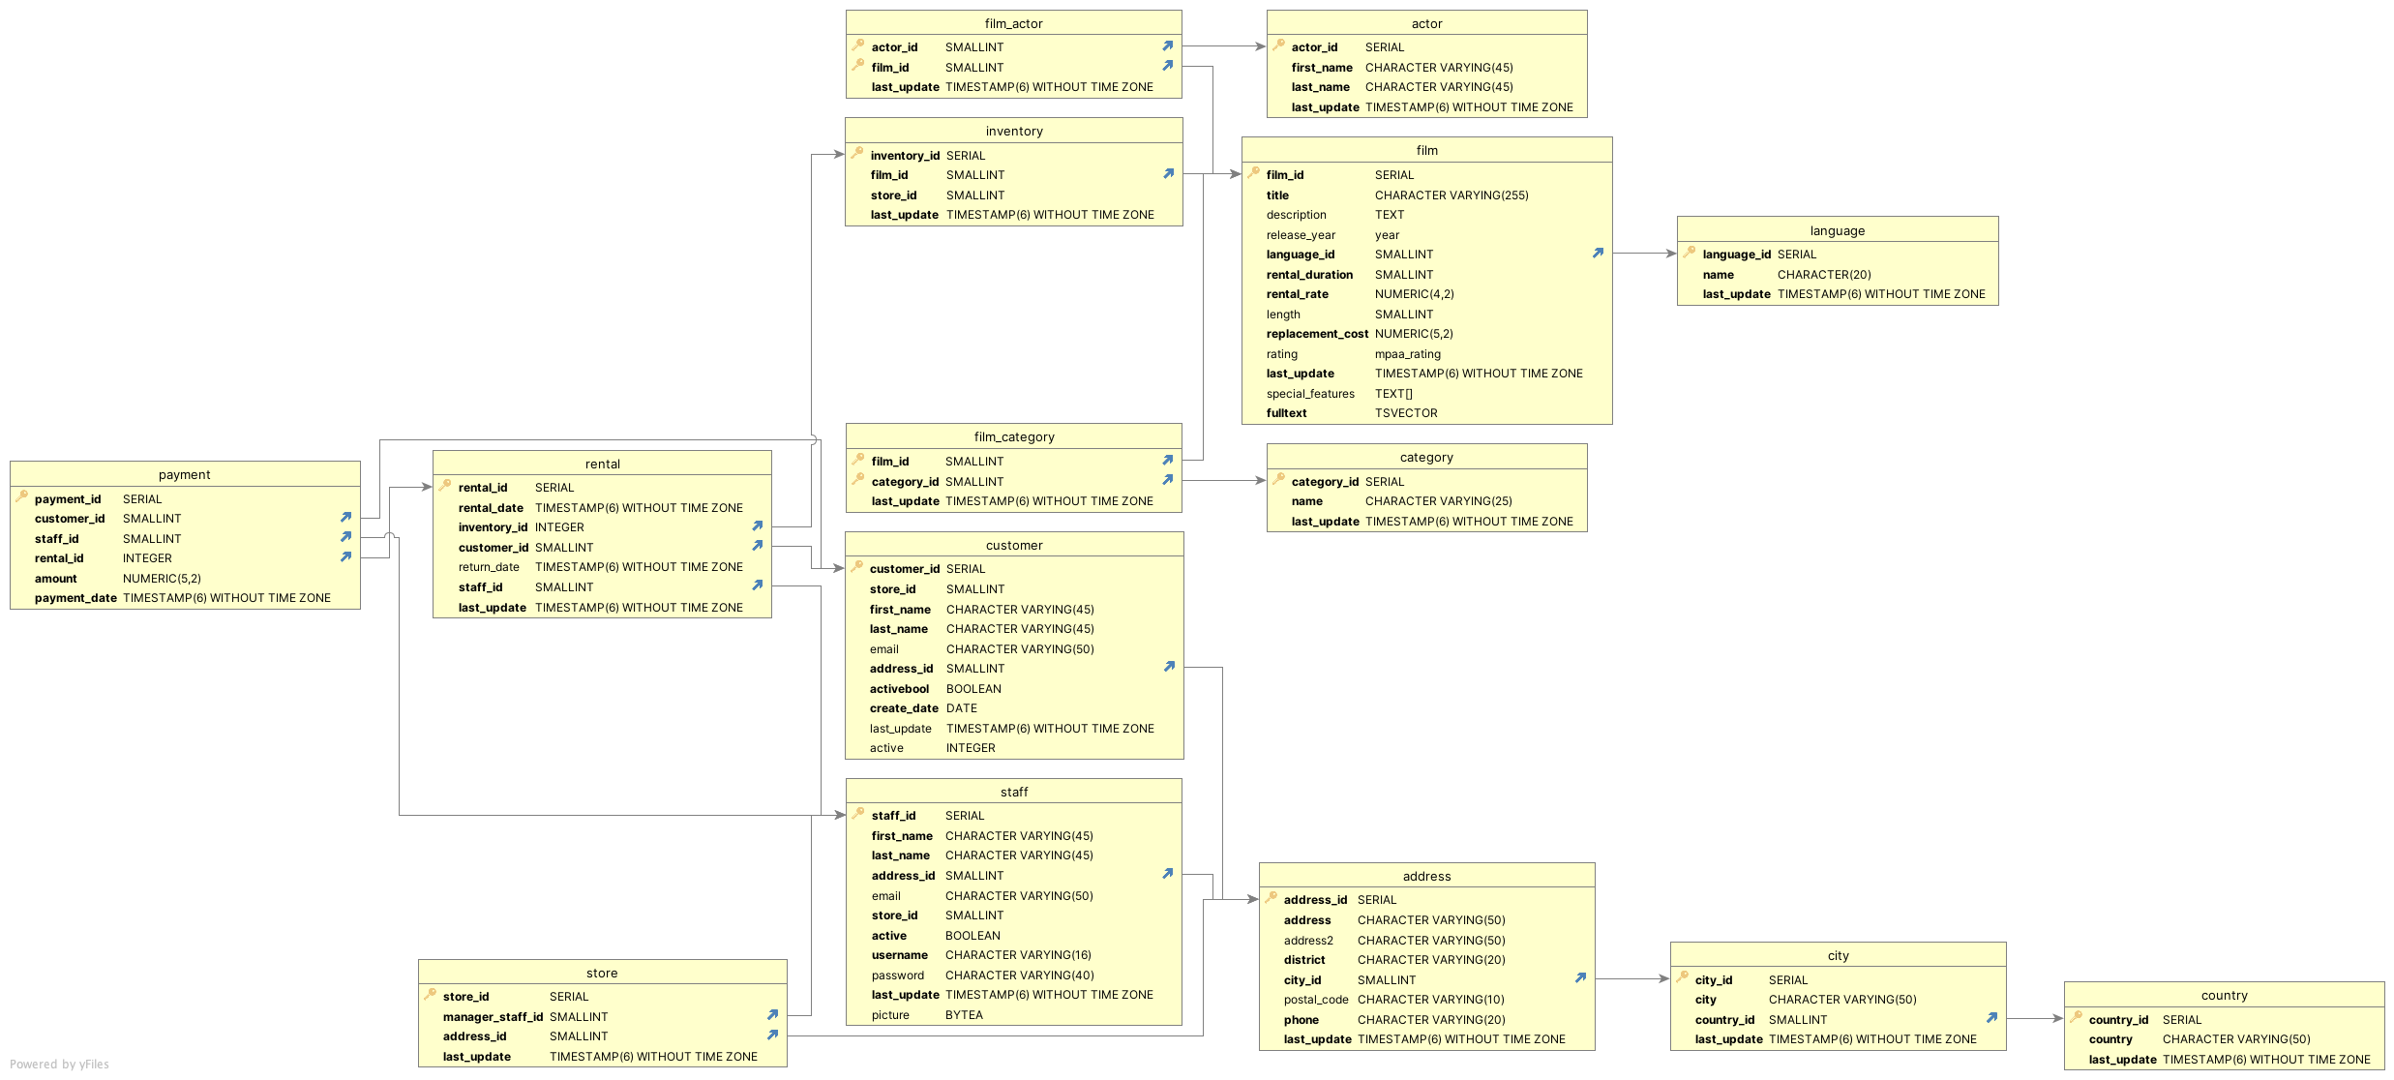

# 3. Tables

**Legend key**

**Primary key:**

**Foreign key:**

## 3.1 Payment table:

|  |  |  |
| --- | --- | --- |
| Column | Data Type | Description |
| payment_id | SERIAL | Unique number identifying each transaction. |
| customer_id | SMALLINT | Unique number identifying the customer. |
| staff_id | SMALLINT | Unique number identifying the staff member |
| rental_id | INTEGER | Unique number for each rental |
| amount | NUMERIC(5,2) | Amount of money for payment |
| payment_date | TIMESTAMP(6) WITHOUT TIME ZONE | Date when payment was made |

**Links to:**

|  |  |
| --- | --- |
| **Table** | **Join** |
| **Customer** | **payment.customer_id=customer.customer_id** |
| **Staff** | **payment.staff_id=staff.staff_id** |
| **Rental** | **payment.rental_id = rental.rental_id** |

## 3.2 Rental table:

|  |  |  |
| --- | --- | --- |
| Column | Data Type | Description |
| rental_id | SERIAL | Unique number for each rental |
| rental_date | TIMESTAMP(6) WITHOUT TIME ZONE | Date of when the item was rented |
| inventory_id | INTEGER | Unique number identifying the unit in inventory |
| customer_id | SMALLINT | Unique number identifying the customer |
| return_date | TIMESTAMP(6) WITHOUT TIME ZONE | Date of when the item was returned |
| staff_id | SMALLINT | Unique number identifying the staff member |

**Links to:**

|  |  |
| --- | --- |
| **Table** | **Join** |
| **Inventory** | **Rental.inventory_id=inventory.inventory_id** |
| **Customer** | **Rental.customer_id=customer.customer_id** |
| **Staff** | **Rental.staff_id=staff.staff_id** |

**Linked from:**

|  |  |
| --- | --- |
| **Table** | **Join** |
| **Payment** | **Payment.rental_id=rental.rental_id** |

## 3.3 Film_actor table:

|  |  |  |
| --- | --- | --- |
| Column | Data Type | Description |
| actor_id | SMALLINT | Unique number identifying the actor |
| film_id | SMALLINT | Unique number identifying the film |
| last_update | TIMESTAMP(6) WITHOUT TIME ZONE | Date when the movie was last updated |

**Links to:**

|  |  |
| --- | --- |
| **Table** | **Join** |
| **actor** | **Film_actor.actor_id=actor.actor_id** |
| **Film** | **Film_actor.film_id=film.film_id** |

## 3.4 Inventory table:

|  |  |  |
| --- | --- | --- |
| Column | Data Type | Description |
| inventory_id | SERIAL | Unique number identifying each rental unit in inventory |
| film_id | SMALLINT | Unique number identifying the film |
| store_id | SMALLINT | Unique number identifying the store |
| last_update | TIMESTAMP(6) WITHOUT TIME ZONE | Date when this table was last updated |

**Links to:**

|  |  |
| --- | --- |
| **Table** | **Join** |
| **Film** | **Inventory.film_id=film.film_id** |

**Linked from:**

|  |  |
| --- | --- |
| **Table** | **Join** |
| **Rental** | **Rental.inventory_id=inventory.inventory_id** |

## 3.5 Film_category table:

|  |  |  |
| --- | --- | --- |
| Column | Data Type | Description |
| film_id | SMALLINT | Unique number identifying the film |
| category_id | SMALLINT | Unique number identifying the films category |
| last_update | TIMESTAMP(6) WITHOUT TIME ZONE | Date when this table was last updated |

**Links to:**

|  |  |
| --- | --- |
| **Table** | **Join** |
| **Film** | **Film_category.film_id=film.film_id** |
| **Category** | **Film_category.category_id= category.category_id** |

## 3.6 Customer table:

|  |  |  |
| --- | --- | --- |
| Column | Data Type | Description |
| customer_id | SERIAL | Unique number identifying the customer |
| store_id | SMALLINT | Unique number identifying the store |
| first_name | CHARACTER VARYING(45) | First name of the customer |
| last_name | CHARACTER VARYING(45) | Last name of the customer |
| email | CHARACTER VARYING(50) | Customers email |
| address_id | SMALLINT | Unique number for the customer’s address |
| activebool | BOOLEAN | True or False for if the customer is currently an active customer |
| create_date | DATE | The date the customer’s account was created |
| last_update | TIMESTAMP(6) WITHOUT TIME ZONE | Date when this table was last updated |
| active | INTEGER | A 0 or 1 indicating the customer’s active status |

**Links to:**

|  |  |
| --- | --- |
| **Table** | **Join** |
| **Store** | **Customer.store_id =store.store_id** |
| **Address** | **Customer.address_id=address.address_id** |

**Linked from:**

|  |  |
| --- | --- |
| **Table** | **Join** |
| **Payment** | **Payment.rental_id=rental.rental_id** |
| **Rental** | **Rental.customer_id=customer.customer_id** |

## 3.7 Staff table:

|  |  |  |
| --- | --- | --- |
| Column | Data Type | Description |
| staff_id | SERIAL | Unique number identifying the staff member |
| first_name | CHARACTER VARYING(45) | First name of the staff member |
| last_name | CHARACTER VARYING(45) | Last name of the staff member |
| address_id | SMALLINT | Unique number for the staff’s address |
| email | CHARACTER VARYING(50) | Email address of staff member |
| store_id | SMALLINT | Unique number identifying the store |
| active | BOOLEAN | True or False for if the staff member is currently an active staff member |
| username | CHARACTER VARYING(16) | Staff member username |
| password | CHARACTER VARYING(40) | Staff member password |
| last_update | TIMESTAMP(6) WITHOUT TIME ZONE | Date when this table was last updated |
| picture | BYTEA | Photo of staff member |

**Links to:**

|  |  |
| --- | --- |
| **Table** | **Join** |
| **Address** | **Staff.address_id=address.address_id** |
| **Store** | **Staff.store_id=store.store_id** |

**Linked from:**

|  |  |
| --- | --- |
| **Table** | **Join** |
| **Payment** | **Payment.staff_id=** |
| **Store** | **Store.manager_staff_id=staff.manager_staff_id** |

## 3.8 Store table:

|  |  |  |
| --- | --- | --- |
| Column | Data Type | Description |
| store_id | SMALLINT | Unique number identifying the store |
| manager_staff_id | SMALLINT | Unique number identifying the manager |
| address_id | SMALLINT | Unique number identifying the store |
| last_update | TIMESTAMP(6) WITHOUT TIME ZONE | Date when this table was last updated |

**Links to:**

|  |  |
| --- | --- |
| **Table** | **Join** |
| **Staff** | **Store.manager_staff_id=staff.manager_staff_id** |
| **Address** | **Store.address_id=address.address_id** |

## 3.9 Actor table:

|  |  |  |
| --- | --- | --- |
| Column | Data Type | Description |
| actor_id | SERIAL | Unique number given to each actor |
| first_name | CHARACTER VARYING(45) | Actors first name |
| last_name | CHARACTER VARYING(45) | Actors last name |
| last_update | TIMESTAMP(6) WITHOUT TIME ZONE | Date when this table was last updated |

**Links to:**

|  |  |
| --- | --- |
| **Table** | **Join** |
| **Film** | **Actor.actor_id=film_actor.actor_id** |

## 3.10 Film Table:

|  |  |  |
| --- | --- | --- |
| Column | Data Type | Description |
| film_id | SERIAL | Unique number identifying the film |
| title | CHARACTER VARYING(225) | Title of the film |
| description | TEXT | Description of the film |
| release_year | year | The year the film was released |
| language_id | SMALLINT | The language of the film |
| rental_duration | SMALLINT | The length of the rental in days |
| rental_rate | NUMERIC(4,2) | Price of rental |
| length | SMALLINT | Length of the film |
| replacement_cost | NUMERIC(5,2) | Cost of replacing the film if lost |
| rating | mpaa_rating | Rating given to each film by the mpaa |
| last_update | TIMESTAMP(6) WITHOUT TIME ZONE | Data for when this table was last updated |
| special_features | TEXT[] | Special features that accompany the film |
| fulltext | TSVECTOR | Text search vectors for full tilm text searches |

**Links to**

|  |  |
| --- | --- |
| **Table** | **Join** |
| **Language** | **Film.languange_id=language.language_id** |

**Linked from:**

|  |  |
| --- | --- |
| **Table** | **Join** |
| **Film_actor** | **Film.actor.film_id=film.film_id** |
| **inventory** | **Inventory.film_id=film.film_if** |
| **Film_category** | **Film_category.film_id=film.film_id** |

## 

## 3.11 Category table:

|  |  |  |
| --- | --- | --- |
| Column | Data Type | Description |
| category_id | SERIAL | Unique number identifying the films category |
| name | CHARACTER VARYING(25) | Name of the category |
| last_update | TIMESTAMP(6) WITHOUT TIME ZONE | Date when this table was last updated |

**Linked from:**

|  |  |
| --- | --- |
| **Table** | **Join** |
| **Film_category** | **Film_category.category_id= category.category_id** |

## 3.12 Address table:

|  |  |  |
| --- | --- | --- |
| Column | Data Type | Description |
| address_id | SERIAL | Unique number identifying the address |
| address | CHARACTER VARYING(50) | Street address |
| address2 | CHARACTER VARYING(50) | Second line of street address if needed |
| district | CHARACTER VARYING(20) | State, province, or territory of address |
| city_id | SMALLINT | Unique number given to each city |
| postal_code | CHARACTER VARYING(10) | Postal code for each address |
| phone | CHARACTER VARYING(20) | Phone number for each customer |
| last_update | TIMESTAMP(6) WITHOUT TIME ZONE | Date when this table was last updated |

**Links to:**

|  |  |
| --- | --- |
| **Table** | **Join** |
| **Address** | **Address.city_id=city.city_id** |

**Linked from:**

|  |  |
| --- | --- |
| **Table** | **Join** |
| **Customer** | **Cutomer.address_id=address.address_id** |
| **Staff** | **Staff.address_id=address.address_id** |
| **Store** | **Store.address_id=address.address_id** |

## **3.13 Language table:**

|  |  |  |
| --- | --- | --- |
| Column | Data Type | Description |
| language_id | SERIAL | Unique number identifying the films language |
| name | CHARACTER VARYING(20) | Name of the language |
| last_update | TIMESTAMP(6) WITHOUT TIME ZONE | Date when this table was last updated |

**Linked from:**

|  |  |
| --- | --- |
| **Table** | **Join** |
| **Film** | **Language.languange_id=film.language_id** |

## **3.14 City table:**

|  |  |  |
| --- | --- | --- |
| Column | Data Type | Description |
| city_id | SERIAL | Unique number identifying the city |
| city | CHARACTER VARYING(50) | Name of the city |
| country_id | SMALLINT | Unique number given to each country |
| last_update | TIMESTAMP(6) WITHOUT TIME ZONE | Date when this table was last updated |

**Links to:**

|  |  |
| --- | --- |
| **Table** | **Join** |
| **Country** | **City.country_id=country.country_id** |

**Linked from:**

|  |  |
| --- | --- |
| **Table** | **Join** |
| **Address** | **Address.city_id=city.city_id** |

## **3.15 Country table:**

|  |  |  |
| --- | --- | --- |
| Column | Data Type | Description |
| country_id | SERIAL | Unique number given to each country |
| country | CHARACTER VARYING(50) | Name of the country |
| last_update | TIMESTAMP(6) WITHOUT TIME ZONE | Date when this table was last updated |

**Linked from:**

|  |  |
| --- | --- |
| **Table** | **Join** |
| **city** | **City.country_id=country.country_id** |